SEMIOTICS OF THE 'A WOMAN IN A PINK HIJAB' PHOTO ON HARIAN KOMPAS' INSTAGRAM
Muhammad Rhomy Dellan, M.I.Kom¹, Bramedia Ridho Satria, M.I.Kom², & Satria Sofyan Pramadia, M.I.Kom³
¹LSPR Institute of Communication and Business, Jakarta, Indonesia
Corresponding author: bramedia.rs@lspr.edu
ABSTRACT
Instagram is now a very graphic platform in terms of news flow and can make a photojournalistic picture a digital icon. The paper is an analysis of a photo series of the a woman in a pink hijab which was posted by Harian Kompas on 28 August 2025 during a demonstration in front of the Indonesian House of Representatives (DPR RI). The paper poses the question of how visual displays - the pink hijab, riot shields, the Indonesian flag, and bodily gestures - produce a meaning of gender, civic identity, and symbolic resistance. It employs a descriptive qualitative research design to apply Barthesian signification orders (denotation, connotation, myth) to four photographs in a single carousel post and triangulate the discourse of the mainstream news about the concept of ‘pink brave’. The analysis finds that denotatively the images document a civilian-police confrontation. Connotatively, color contrast and barricade composition foreground an opposition between 'ordinary people' and state power while renegotiating stereotypical femininity into moral courage. At mythic level the mother comes out as a symbol of civic motherhood that defines resistance as a form of patriotism when the flag is raised during war. This research discovered that Instagram photojournalism does not merely report on situations, but it integrates sense into symbols that could be exchanged on the digital open platform.
Keywords: Semiotics; Roland Barthes; Photojournalism; Instagram; Gender Representation

1. INTRODUCTION
Developments in platform-based communication have transformed the access, distribution, and exchange of information by people. Social platforms in the modern news ecosystem serve as spaces where news is repackaged to align with the abilities, metrics, and expectations of the audiences of the platform a process becoming more frequently referred to as the platformization of news (Hase et al., 2023). Mass audience research also reveals that social media have emerged as a major source of news especially among younger consumers even though the issue of verification is still debatable (Reuters Institute to Study of Journalism, 2023).
Instagram is one of the platforms, which focus more on visuals, most of the images are photos and short videos. This is the reason why Instagram becomes a viable visual journalism tool to cover events that affect the population as it will be possible to report the occasion with a bunch of pictures in a carousel format that can be easily viewed, saved and shared. On the methodological level, recent studies have suggested ways of gathering, classifying, and interpreting the images on the platform and how they are spread, therefore making Instagram an important location of visual media studies (Rogers, 2021). Meanwhile the news platforms change the choice of stories and visual display to platform capabilities and perceived preference (Hase et al., 2023).
In photojournalism tradition, photograph is frequently dealt with as an evidence of what happened. However, the meaning as highlighted by recent scholarship is not necessarily the one depicted but rather in the circumstances of circulation and recontextualization over the internet. Mass analyses of iconic photographs indicate that captions, contextual texts, and remix practices form the iconic photographs online identities shaping the means of generating varying meanings over time and platform (Smits and Ros, 2023). In this respect, photographic journalistic images are not simply the records; they have the power to solidify the political discourses and emotional leanings as they go round.
The case under consideration in this research is a series of photographs of the image of a woman in a pink hijab by a post of Harian Kompas Instagram (28 August 2025) depicting a lady on the frontline against riot-control officers. Visual opposition (a pink hijab in a conflict situation and the Indonesian flag (Merah Putih)) was in news content and on-line discussion, associated with a virality and the appearance of the pink brave symbol in protest waves towards the end of August 2025 (Ramdani, 2025; Harahap, 2025). The unusual aspect of this phenomenon is that one figure can be viewed at the same time as a gender representation (woman/mother), religious identification (hijab), and citizenship (national flag) and such interpretations are promoted and debated in the popular arena.
Based on this background, the research considers photographs as sign systems, which can be read in various levels of meaning. In the extensive Barthesian semiotics which is still actively operationalized in modern visual-communication research, scholars differentiate between denotation (literal description), connotation (cultural association), and myth (naturalized ideology) to describe how the work of representation in culture happens (Chandler, 2022; Halim and Patriansah, 2023). Pink is extensively ingrained in gendered discourse, as corpus-based data of written texts reveals that pink is very feminine- and positivity-biased (Jonauskaite et al., 2021). These traditional associations create the semantic tension inviting interpretation when they are put in the context of a confrontational protest.
Past research in visual semiotics tend to treat individual photographs or the print/online news media alone, whereas the analysis of photojournalistic sequences on Instagram is comparatively scarce, especially in the context of myth readings being connected to platformization and virality. Thus, the given research is useful as it provides a semiotic interpretation of a photo series that circulates in the environment of Instagram as the source of news and a symbolic circulation zone.
This study poses the following research questions: (1) How is sign structure organized at the denotative level in the 'a woman in a pink hijab' photo sequence posted by Harian Kompas on Instagram? (2) What connotative meanings are constructed through visual elements such as color, bodily gesture, objects (shields, batons, flag), and composition? (3) What myths or ideologies are naturalized through the representation of a 'mother' in a citizen-police conflict situation? (4) How does the distribution context on Instagram help shape the photos as symbols or digital icons?
This article follows the IMRaD format. The methodology section explains the research design and analytic procedures. The results and discussion section presents the semiotic reading of each photograph and synthesizes the findings. The conclusion summarizes implications and limitations of the study.
2. METHODOLOGY
The method of research was qualitative descriptive with a semiotic analysis method. The qualitative approach can be used due to its emphasis on the semantic interpretation instead of quantitative measurement, which can help comprehensively understand the symbols and the context of the underlying culture (Creswell and Creswell, 2022).
The study object is a one Instagram post of Harian Kompas of 28 August 2025 that includes four consecutive photos that capture a mass action around the DPR RI building. The four images are taken as a series due to the visual story being made using the carousel arrangement within a single posting. The information was gathered in the form of documentation (screenshots) of the post, where the information about the photo credit appeared on the pictures.
The unit of analysis consists of the visible visual signs in the photographs, including: (a) color and clothing attributes (especially the pink hijab), (b) body gestures and the subject's position, (c) objects present (shields, helmets, batons, the Indonesian flag, puddles, debris), (d) spatial relations between civilians and police, and (e) composition, viewpoint, and visual focus. These elements are treated as signifiers that produce signification across multiple levels of meaning (Rose, 2022).
The analytic procedure follows Barthesian orders of signification. First, a denotative description records what is visible (who/what, where, and how objects relate). Second, connotative interpretation links visual elements to cultural conventions (e.g., gendered associations of color, national symbolism of the flag, and symbols of power in shields and batons). Third, a myth reading identifies ideologies naturalized through the photographs, such as how the representation of a "mother" may construct a moral narrative about citizens and power (Chandler, 2022; Halim & Patriansah, 2023).
To improve credibility, the interpretations were made within the group of co-authors (peer debriefing) and were triangulated with mainstream news coverage of the virality of the 'pink brave' symbol at the same time (Creswell and Creswell, 2022). The triangulation in this case does not aim at demonstrating one definitive meaning, but rather at validating the coherence of circumstance and discourses that encompose the circulation of the photos.
This research is ethically based on socially accessible content of social media. The individuality of the person depicted in pictures is not brought up; she is examined as a sign in photojournalism and the development of discourse.
This work as a conceptual point of reference fits in the recent literature on applying Barthesian semiotics to Instagram and other visual image platforms, demonstrating that denotation-connotation-myth is still useful in deconstructing modern-day images (Halim and Patriansah, 2023; Rogers, 2021). Visual grammar methods are used to specify the meaning in terms of composition and color (Kress and van Leeuwen, 2021), and visual research methods consider reflexive and ethical interpretation (Rose, 2022).
3. RESULT AND DISCUSSION
The four photographs under consideration create a visual account of the conflict between the civilians and the police dealing with the riots. On the whole, the order places the woman in pink hijab as the figure of focus with the contrast of color and her location at the forefront of the barricade. Conversely, the police are portrayed as a uniform group to the extent of repetitive quality (helmets, shields with the name of the organization (POLISI) and tight line formations). The trend is the same: civilians are shown as individuals or small groups of people moving dynamically, and the police are shown as an organized, stationary structure. This contrast is a set up to read power imbalance and conflict between civic articulation and state authority.
The discussion below is presented per photograph using three levels of reading: denotation, connotation, and myth. In addition, each image is read as part of a sequence, so its meaning is also shaped by relations between frames - for example, a shift from symbolic gestures (raising a hand, standing defiantly) toward harder interaction (physical clash) and the use of the flag as a marker of nationalism in a conflict situation.

3.1 Photo 1: The Pink-Hijab Figure Facing a Shield Barricade
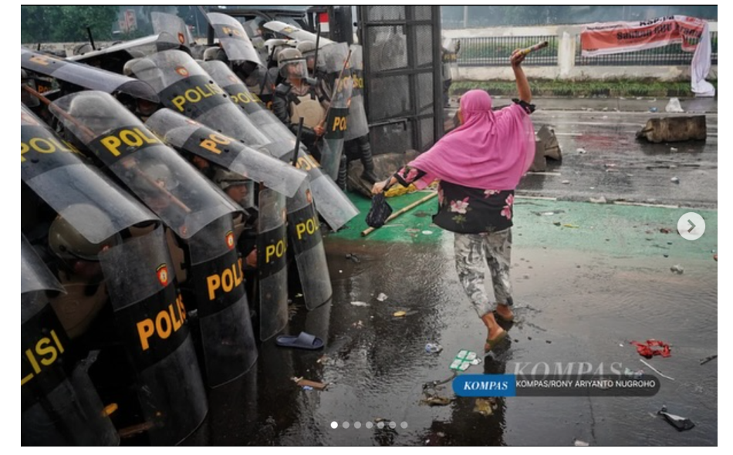
Figure 1. A woman in a pink hijab confronts a barricade of police shields. Source: Harian Kompas Instagram post (2025) / photo credit on image: Kompas/Rony Ariyanto Nugroho.
Denotation | Connotation | Myth/Ideology
A woman wearing a pink hijab is seen from behind moving toward a line of riot-control police (helmets and shields labeled 'POLISI'). She raises an object in her right hand. The road surface is wet with puddles and scattered debris, suggesting an aftermath of disorder or water-cannon dispersal. | The tight police line with layered shields connotes state power, authority, and control. The woman standing alone - without protection - connotes an ordinary citizen confronting structural power. The raised hand holding an object signals refusal, anger, or symbolic resistance. The hijab marks a cultural-religious identity that encounters the security apparatus directly in public space. | The photo produces a myth of the 'mother' as a moral voice: a maternal figure typically associated with domesticity appears as a defender of public values. The dissimilarity of the pink and the police equipments gives the story of the heroism of “ordinary” citizens in the struggle against injustices a symbolic touch. Therefore, the war is not merely a physical battle, but also a moral story where the citizens request justice of the powerful nation.

Compositionally speaking, the picture focuses on the repetitive nature of the shield located on the left side of the picture to make it look like a mass and mechanical power. Conversely, the woman is set in the center with the contrasting colors and she is positioned in an extremely open environment. This trend strengthens the meaning of power asymmetry that is connotative: “structure” (policy) and agent (citizen). Simultaneously, the pink hijab prompts the common contradiction and connotation of pink and femininity; this contradiction contributes to the increased memorability and expressiveness of the photo (Jonauskaite et al., 2021).
3.2 Photo 2: A Defiant Gesture and the Shield Boundary
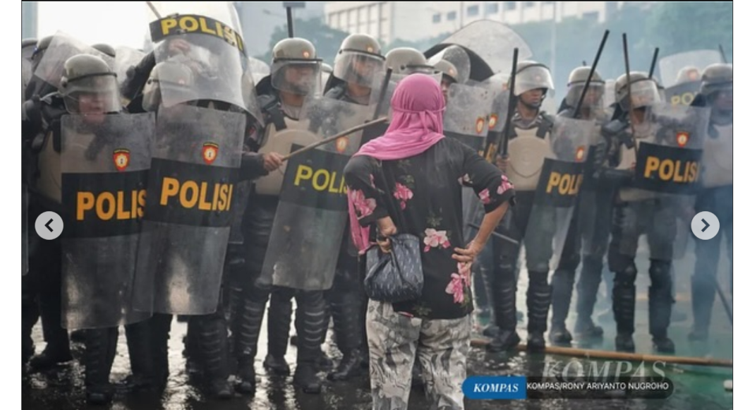
Figure 2. A woman in a pink hijab stands with her hands on her hips facing a line of police. Source: Harian Kompas Instagram post (2025) / photo credit on image: Kompas/Rony Ariyanto Nugroho.
Denotation | Connotation | Myth/Ideology
The woman who is wearing the pink hijab has her back turned to the camera and her hands on her hips. She is confronted by a narrow line of police with shields and sticks. The presence of light smoke/mist and damp pavement implies a mood of disorder or suppressing a crowd. | The proximity but the shields create an obstacle between the subjects and the government. The hands-on- hips position is culturally interpreted as disobedience, assurance and rejection. Institutional dominance and civilian weakness are played out by the disparity between the woman and the officers.The woman is made defenseless, with moral courage being the only form of counter attack. The symbolic war is waged by one person as opposed to the group of officers. | The myth of the steadfastness of the mother in the photo is naturalized to portray ordinary people that are able to speak up in a social space that is usually dominated by men. The female figure is placed in the middle of 'the people' and 'the state' relationship in which is moral legitimacy proposed for the demand. Aesthetically, one body is opposed to a community building and, consequently, courage is seen as civic virtue and not as an emotionality.

In the second photo, dramatization emerges not from physical contact but from a face-to-face confrontation held back by a control device (the shield). The shield functions as a material sign and as a metaphor for a boundary of communication: the citizen is very close, yet access to authority remains mediated and restricted. The firm bodily gesture reinforces a renegotiation of gender identity - the woman is not represented as a passive victim, but as a subject expressing agency in a conflict space.
3.3 Photo 3: The Indonesian Flag as a Claim to Legitimacy
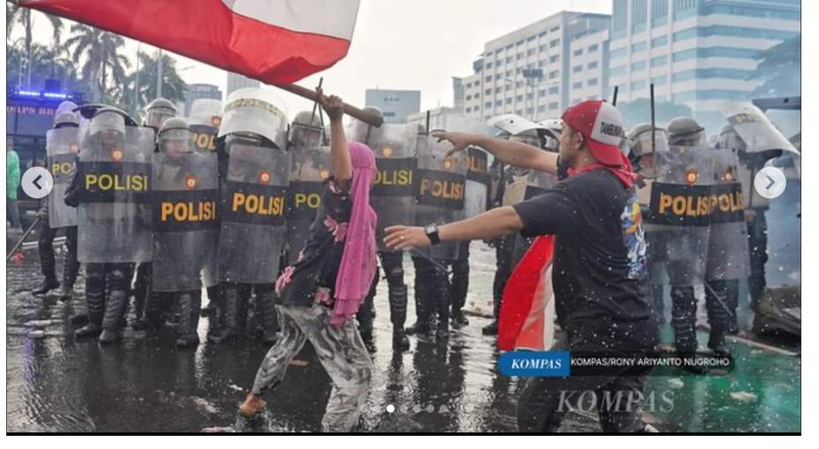
Figure 3. A woman in a pink hijab raises the red-and-white Indonesian flag in front of a police line; another figure appears to signal or direct. Source: Harian Kompas Instagram post (2025) / photo credit on image: Kompas/Rony Ariyanto Nugroho.
Denotation | Connotation | Myth/Ideology
The woman in a pink hijab stands in front of the police line and raises the red-and-white Indonesian flag (Merah Putih). On the right, a man wearing red attributes extends his arm as if directing or signaling. The police remain in tight formation with shields. The background shows an urban area and wet pavement. | The flag is symbolic of the national identity and a right to civic legitimacy. Placing it before police indicates that the protest is more of a civil right and not disorder. The administration of another character signaling can be deciphered as managing mass emotion or staying a safer distance of an encounter. The composition stages a struggle over meaning: the state is represented by the apparatus, while the nation is represented by a shared symbol carried by citizens. | The photo builds a myth of civic nationalism: the flag functions as a 'sacred' and 'shared' sign that grants moral authority to whoever carries it. In this myth, the 'mother' figure raising the flag can be read as a personification of Ibu Pertiwi (Motherland) - not as personal identity but as a metaphor of the nation demanding protection of social justice values. Thus, the conflict is interpreted as a contest over who legitimately represents the nation.

In the third photo, the red-and-white flag shifts the confrontation into a discourse of nationhood. In a chaotic context, the flag can frame resistance as patriotic and make the image legible and shareable as a political statement (Smits & Ros, 2023).
3.4 Photo 4: Physical Clash and a 'Wound' to National Symbols
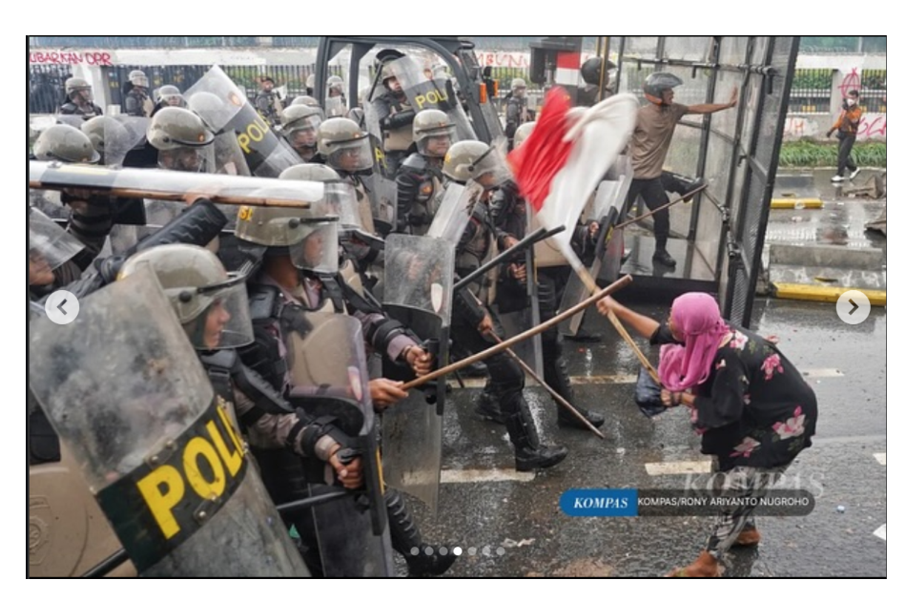
Figure 4. A woman in a pink hijab bends down while holding the flag; police raise batons. Source: Harian Kompas Instagram post (2025) / photo credit on image: Kompas/Rony Ariyanto Nugroho.
Denotation | Connotation | Myth/Ideology
The woman in a pink hijab is bent forward/crouching while holding the Indonesian flagpole (Merah Putih). On the left, police officers wearing helmets and shields raise batons toward her. In the background, vehicles and barriers are visible, the street is wet and there are objects scattered everywhere. | Her bent posture suggests vulnerability and being pushed. Contrasted with the erect position and weaponry of the officers, this reaffirms the concept of dominance and subordination. The fact that the flag was caught in the clash implies a 'symbolic injury' to the national values: the flag, a symbol of national unity, is present during the violence. Connotatively, the image situates the citizen's body as a terrain over which structural conflict is fought. | The photo produces a myth of 'citizen sacrifice' and a legitimacy crisis: when the national symbol appears under threat, audiences may read that what is harmed is not only an individual but also national values. The myth operates through visual dramatization - vulnerable body versus instruments of force - inviting a moral reading of who protects the nation and who threatens it. In a media ecology, such images readily become icons because they compress complex conflict into an emotionally charged scene (Hariman & Lucaites, 2007; Sontag, 2003).

The fourth photo is the denouement and the most direct physical contact is demonstrated and the vulnerability of the civilian body is revealed. This type of scene can evoke the feeling of empathy and one should be angered by the image, which explains why the pink-hijab character was branded as a representative of civic opposition in mainstream media (Harahap, 2025; Hestianingsih, 2025; Ramdani, 2025).
3.5 Synthesis: From a Photo Sequence to a Digital Icon
The readings per photo reveal that the meaning in this order is constructed with the help of contrast and repetition. To begin with, the pink hijab is a visual effect, which reminds the audience of the main character. When discussing the subject of color and gender, pink has become a feminine and positive color; therefore, its usage in conflict scenarios creates a dissonance that disrupts the expectations and raises the visual appeal (Jonauskaite et al., 2021). This contradiction coincides with the online name, pink brave, which includes the description of bravery to a color that is perceived as soft (Ramdani, 2025).
Second, the police are represented through a homogeneous visual pattern: helmets, shields, and tight formations create an impression of mechanical collectivity. This homogeneity makes the police a faceless 'structure' and the civilians, particularly the woman in pink, more personal subjects. Semiotically, the structure-agency opposition facilitates the moral reading typical of myth: a 'weak' individual confronting a 'strong' force.
Third, the Indonesian flag functions as a signifier that links the incident to collective imagination. When the flag appears amid a citizen-police clash, the photo implicitly raises a question: is state order aligned with justice for citizens? This question is not articulated verbally, but staged through visual drama - and precisely for that reason it is easy to circulate and negotiate. Research on iconic photographs' online circulation suggests that images can acquire new political meanings as they are repeatedly recontextualized (Smits & Ros, 2023).
Fourth, the representation of a 'mother' activates a cultural schema of motherhood as a source of moral authority. In many cultural contexts, a mother figure is perceived as a protector and caregiver; when such a figure moves into a confrontation space, she can be read as a 'guardian of values' who admonishes power. This schema is translated into public identification practices: news coverage narrates the figure as a symbol of resistance and the courage of ordinary citizens (Harahap, 2025; Hestianingsih, 2025).
Fifth, Instagram distribution accelerates the transformation of photographs into symbols. The carousel format supports sequential narrative, but cropping and screenshots can detach a single frame from the original context. Platform images are readily reassembled in collections and remix environments, amplifying particular frames (Rogers, 2021). In news contexts, engagement-oriented platformization can further heighten the salience of 'high-contrast' frames and their recontextualization beyond original captions (Hase et al., 2023; Smits & Ros, 2023).
That is why the resulting myth is not only the product of the photographs, but also the product of their utterance in online space. “Pink brave” is a metalanguage that guides reading of the masses and an attempt to propagate a myth of moral valor. According to Barthesian terms, on the one hand, the connotative associations may be hardened into mythology when repeated and normalized in various discursive contexts and the reading itself becomes natural (Chandler, 2022). These processes could also be seen in the modern Instagram visual analysis where repeated captions, hashtags, and posts are used in directing interpretive frames (Halim & Patriansah, 2023).
3.6 Implications: Photojournalism, Virality, and Platform Logic
The photo series “A Woman in a Pink Hijab” depicts the interaction of photojournalistic practices with the platformization conditions. Photos are usually accompanied by textual stories in the traditional media, but on Instagram, it is the primary reading that creates the engagement. This alters the manner in which the news is being consumed: the viewers have the chance to stop on one image, enlarge, store, or repost without understanding the context. Photographic meaning in such an environment is likely to reduce to easily referenced symbols, including the hashtag pinned down as a sign of civic courage, pink brave.
Visibility is also dependent upon algorithmic curation and attention measures. Platform environments are more likely to give preference to the content that brings about engagement, i.e., readable and compelling images have an increased chance to resurface on the recommendations and feeds. Research on news platformization implies that editorial decisions and patterns of exposure to news on platforms such as Instagram can be affected by interaction-based distribution (Hase et al., 2023). In this regard, the photographs with high contrasts pink versus shield, flag versus stick are pictorial details that are in line with the attention economy and speed of spread (Rogers, 2021).
The other implication is associated with ethics of representation. Visual methods of research recognize that they are less likely to cause harm, safeguard personality when it is necessary, and consider the possibilities of recontextualizing images when spreading them online (Rose, 2022). In the context of the media, there is the problem of balancing between information value and representational responsibility especially when one is republishing images without the contextual control. Anonymization of personal identity is deemed important in this study to reduce the chances of stigmatization and yet an analytical concern on signals and public discourse.
4. CONCLUSION
This study demonstrates that a set of images of a woman in pink hijab, posted on the Instagram page of Kompas Daily creates a meaning on three levels. On the denotative level, the photos depict a conflict between the citizens and the police in the middle of a mass protest in the area of the Indonesian Parliament. On the connotative level, the visual means include the contrast of color, the creation of barricades, the gestures of indignation and the Indonesian flag that produce the opposite meanings: individualism and structure, citizenship and authority, and femininity linked with moral courage. The person of the mythical mother represents motherhood and nationalism at the mythical level and naturalizes the story of the people as the protective of justice against power.
These findings affirm that in the Instagram ecosystem, photojournalism does not only cover events but also helps to form the readily reproduced, commentable, and shareable social symbols in the online discourse. The context of the platform (carousel format, shared culture, and metrics of engagement) creates an environment in which one can attribute meaning, which enables the photograph to act as a digital icon.
ETHICAL APPROVAL
This study uses publically available social media content, and does not involve direct interaction with participants. Thus, it was not necessary to obtain formal ethical approval. The analysis does not reveal the personal identity of the Figure in the photos and is focused on the concept of representational meaning in the context of photojournalism.
INFORMED CONSENT STATEMENT
Informed consent does not apply because the study did not collect private data and only used publicly available documentation.
AUTHORS’ CONTRIBUTIONS
Muhammad Rhomy Dellan conceptualized the study and led data collection and analysis. Bramedia Ridho Satria contributed to methodological design and editing. Satria Sofyan Pramadia contributed to literature synthesis and manuscript preparation. All authors reviewed and approved the final manuscript.
DISCLOSURE STATEMENT
The authors declare no conflicts of interest.
DATA AVAILABILITY STATEMENT
Data are from a publicly accessible Harian Kompas Instagram post. Analytic notes are available from the corresponding author upon reasonable request.
FUNDING
This research received no external funding.
NOTES ON CONTRIBUTORS
The authors are lecturers/researchers at the LSPR Institute of Communication and Business with interests in visual communication, journalism, and semiotics.

REFERENCES
Chandler, D. (2022). Semiotics: The basics (4th ed.). Routledge.
Creswell, J. W., & Creswell, J. D. (2022). Research design: Qualitative, quantitative, and mixed methods approaches (6th ed.). SAGE.
Halim, B., & Patriansah, M. (2023). Kajian semiotika Roland Barthes pada feed Instagram Tri pasca merger dengan Indosat. Narada: Jurnal Desain & Seni, 10(2), 143–164. https://doi.org/10.22441/narada.2023.v10.i2.002
Harahap, L. (2025, August 30). Aksi berani emak-emak kerudung pink di tengah ricuh demo depan DPR mencuri perhatian. Liputan6.com. https://www.liputan6.com/news/read/6146359/aksi-berani-emak-emak-kerudung-pink-di-tengah-ricuh-demo-depan-dpr-mencuri-perhatian
Harian Kompas. (2025, August 28). [Instagram post]. Instagram. https://www.instagram.com/p/DN5wxOdE-RR/
Hartono, H., Margaretha, R., & Afrilia, N. S. (2026). Visual representation of strength and masculinity in male supplement product packaging. Priviet Social Sciences Journal, 6(1), 283–294. https://doi.org/10.55942/pssj.v6i1.569
Hase, V., Boczek, K., & Scharkow, M. (2023). Adapting to affordances and audiences? A cross-platform, multi-modal analysis of the platformization of news on Facebook, Instagram, TikTok, and Twitter. Digital Journalism, 11(8), 1499–1520. https://doi.org/10.1080/21670811.2022.2128389
Hestianingsih. (2025, August 29). Momen ibu jilbab pink lawan aparat, simbol perlawanan saat demo DPR. detikBali. https://www.detik.com/bali/berita/d-8086104/momen-ibu-jilbab-pink-lawan-aparat-simbol-perlawanan-saat-demo-dpr
Jonauskaite, D., Sutton, A., Cristianini, N., & Mohr, C. (2021). English colour terms carry gender and valence biases: A corpus study using word embeddings. PLOS ONE, 16(6), e0251559. https://doi.org/10.1371/journal.pone.0251559
Kress, G., & van Leeuwen, T. (2021). Reading images: The grammar of visual design (3rd ed.). Routledge.
Ramdani, D. N. (2025, September 3). Sejarah warna pink dan hijau, kini jadi simbol brave pink hero green. detikJabar. https://www.detik.com/jabar/jabar-gaskeun/d-8094531/sejarah-warna-pink-dan-hijau-kini-jadi-simbol-brave-pink-hero-green
Reuters Institute for the Study of Journalism. (2023). Digital news report 2023. University of Oxford. https://reutersinstitute.politics.ox.ac.uk/digital-news-report/2023
Rogers, R. (2021). Visual media analysis for Instagram and other online platforms. Big Data & Society, 8(1), 1–23. https://doi.org/10.1177/20539517211022370
Rose, G. (2022). Visual methodologies: An introduction to researching with visual materials (5th ed.). SAGE.
Smits, T., & Ros, R. (2023). Distant reading 940,000 online circulations of 26 iconic photographs. New Media & Society, 25(12), 3543–3572. https://doi.org/10.1177/14614448211049459

