

A strategic model to enhance the competitiveness of halal MSMEs through halal certification, digital marketing, and creative branding

Surya Bakti*, Tengku Syarifah, Nurul Hikmatul Alawiyah, M. Sandi Syahputa, Dea Mutia

Faculty of Economy, Universitas Asahan, Jl. Latsitarda Nusantara VIII No.9, Kisaran Naga, Kec. Kota Kisaran Timur, Kabupaten Asahan, Sumatera Utara 21211, Indonesia
e-mail: suryabakti@una.ac.id

Received 24 October 2025
Revised 27 December 2025
Accepted 30 December 2025

ABSTRACT

This community service program was conducted to enhance the competitiveness of halal MSMEs in Binjai Baru Village, Datuk Tanah Datar District, Batu Bara Regency, North Sumatera Province, Indonesia, through three key interventions: halal certification awareness, digital marketing training, and creative branding workshops. The primary issues faced by MSMEs in this area include a limited understanding of halal certification procedures, low utilization of digital platforms for promotion, and weak brand identity, which affects product attractiveness. The program’s implementation method consisted of preparation, execution, and evaluation stages involving field observation, awareness sessions, hands-on digital marketing practice, and branding assistance. The results indicate a significant improvement in the participants’ understanding of the benefits of halal certification, their ability to use social media for product promotion, and their initial skills in designing brand identities and product packaging. The participants demonstrated high enthusiasm and were able to gradually apply the materials provided. Overall, this program successfully strengthened the legal, digital marketing, and branding capacities of local MSMEs, forming a solid foundation for enhancing sustainable competitiveness in the halal industry.

Keywords: Halal MSMEs, Halal Certification, Digital Marketing, Creative Branding, Community Service.



1. INTRODUCTION
Micro, Small, and Medium Enterprises (MSMEs) are a key pillar of the Indonesian economy because of their role in generating employment, reducing income inequality, and contributing to national economic growth. Amid rising public awareness of the importance of halal products, halal MSMEs have a strategic opportunity to expand their market share and enhance their competitiveness. However, various studies indicate that most halal MSMEs still face limitations in meeting halal certification standards, utilizing digital technology, and building a strong brand identity (Widigdo & Triyanto, 2024). These conditions weaken consumer trust, restrict market access, and lower the competitive position of halal MSMEs in an increasingly competitive industry (Utami et al., 2023). Simultaneously, the halal MSME sector has demonstrated significant resilience in the face of fluctuations in global economic conditions (Arista and Hermawan, 2025; Mahfud, 2025).
Halal certification is an essential instrument for ensuring the quality, safety, and integrity of halal products. Although the government has introduced various facilitation programs, such as free certification schemes and technical assistance, MSME actors regarding the procedures and’ halal certification literacy remains relatively low. Many business owners perceive the certification process as complex and costly, making them reluctant to apply. Halal certification not only strengthens consumer trust but also provides a competitive advantage that can open access to the rapidly growing global halal market. MSMEs contribute significantly to job creation, economic growth, and improvement of overall community welfare (Mahfud, 2025; Hidayat & Witta, 2024).
Digital transformation is a crucial factor in enhancing halal MSMEs’ competitiveness. The shift in consumer behavior toward digital consumption patterns requires MSMEs to adopt effective digital marketing strategies (Handy et al., 2024; Nurjamjam, 2024). By leveraging social media, marketplaces, websites, and digital content, MSMEs can broaden their promotional reach, increase brand visibility, and strengthen their interaction with customers. However, low levels of digital literacy and limited technical capabilities among MSME owners mean that the use of digital marketing remains suboptimal and has not yet had a significant impact on competitiveness. One such strategy is the implementation of digitalization as a way for businesses to adapt to the digital transformation era (Panduwinata et al., 2025; Arista & Hermawan 2025).
In addition to certification and digital marketing, creative branding plays a strategic role in creating differentiation and shaping product image. In an increasingly competitive halal market, a strong brand identity can enhance perceptions of quality, foster consumer trust, and reinforce loyalty. Yet many halal MSMEs still lack the capacity to design branding strategies that are consistent, appealing, and aligned with product characteristics (Widigdo & Triyanto, 2024; Utami et al., 2023). Limited creativity, insufficient design knowledge, and a lack of understanding of the importance of storytelling in marketing are major obstacles that weaken the competitiveness of halal MSMEs. Branding strategies and digital innovation are viewed as key solutions to improving MSME competitiveness and supporting local economic growth (Amirudin et al., 2025; Silalahi, 2024).
This context is highly relevant to the condition of MSMEs in Binjai Baru Village, Datuk Tanah Datar Subdistrict, Batu Bara Regency, North Sumatra, which is the site of this community service program. Most MSME actors in this area still operate at a small scale, with limited access to information, minimal guidance related to halal certification, and low utilization of digital technology in marketing (Hidayat & Witta, 2024). In addition, many MSMEs in Binjai Baru Village do not yet have a strong brand identity, making it difficult for them to compete with similar products from other regions. This situation underscores the importance of academic intervention and direct assistance to help local MSMEs improve their competitiveness through targeted and sustainable strategies. Halal certification can generate positive impacts for micro enterprises, particularly in increasing sales. Halal certification can generate positive impacts for micro enterprises, especially in boosting sales (Septiani & Ridlwan, 2020; Muhnidin & Br. Pinem, 2024).
At the same time, the expansion of the global halal industry, which is valued in the trillions of dollars, presents major opportunities for Indonesian MSMEs, including those in Batu Bara Regency. Demand for halal products comes not only from Muslim-majority countries, but also from non-Muslim countries that are beginning to recognize the cleanliness, safety, and quality standards inherent in halal products. These opportunities can only be fully utilized if local MSMEs are able to improve product legality, strengthen digital strategies, and adopt more professional branding approaches. MSME entities in Indonesia compete not only with domestic businesses but also with multinational corporations (Arista & Hermawan, 2025).
Nevertheless, the implementation of halal certification in rural areas such as Binjai Baru still faces various structural obstacles, including limited access to information, inadequate mentoring, and negative perceptions of the certification process. This reveals a gap between government policies and actual conditions on the ground, which indicates the need for empowerment models that are more practical, straightforward, and easy for MSME actors to understand. Targeted socialization of halal certification is a crucial step in building understanding and interest among business owners in formalizing the halal status of their products. Simplifying regulations and legal frameworks is also important to make it easier for MSMEs to obtain halal certification, given that the complexity of the current process remains a major barrier for many business actors (Fathoni et al., 2025).
Beyond bureaucratic and technological challenges, ongoing digital development also requires local MSMEs to move quickly in adopting modern marketing strategies. The use of social media, digital content, and e-commerce platforms has become a basic capability that MSMEs must possess in order to compete in a highly competitive market. MSMEs in Binjai Baru Village that can utilize digital technology effectively will have greater opportunities to increase product visibility, strengthen customer relationships, and build sustainable competitive advantages. Many MSMEs have yet to make optimal use of digital technology and social media to promote their products (Panduwinata et al., 2025).
In response to these challenges and opportunities, this community service program aims to develop a strategic model for enhancing the competitiveness of halal MSMEs through the integration of halal certification, digital marketing, and creative branding tailored to the conditions of MSMEs in Binjai Baru Village. Through education, mentoring, and training, the program is expected to make a tangible contribution to strengthening the capacity of local MSMEs and reinforcing the role of academics in community empowerment, particularly in the development of the halal industry in Batu Bara Regency and North Sumatra. Efforts undertaken by MSME actors to face global and national market competition include increasing halal certification for their products (Aulia et al., 2025; Laksono & Imanina, 2025).

2. METHODOLOGY
The community service activities in Binjai Baru Village, Datuk Tanah Datar Subdistrict, Batu Bara Regency were implemented through three main stages: preparation, implementation, and evaluation– mentoring, each designed to respond directly to the conditions and needs of local MSMEs.
In the preparation stage, the team conducted field observations and informal interviews with MSME owners to map the types of businesses, existing marketing practices, and their level of awareness regarding halal certification. This was followed by a needs assessment to identify gaps in knowledge and skills related to halal certification procedures, the use of digital platforms for promotion, and the development of brand identity. Based on these findings, training materials were prepared that combined conceptual explanations with practical guidelines on halal certification, digital marketing, and creative branding, adapted to the socioeconomic context of Binjai Baru.
The implementation stage consisted of three core activity streams. First, the socialization of halal certification focused on explaining the regulatory framework, benefits, and step-by-step procedures for applying through the Sihalal platform. Second, digital marketing training was delivered through hands-on practice using smartphones and laptops, where participants were guided to create business accounts, design basic content, and utilize promotional features on social media and marketplaces. Third, creative branding training emphasized the design of brand identity elements such as logos, color schemes, product packaging, and simple storytelling techniques to communicate product uniqueness and halal attributes (See Figure 1 for the documentation).

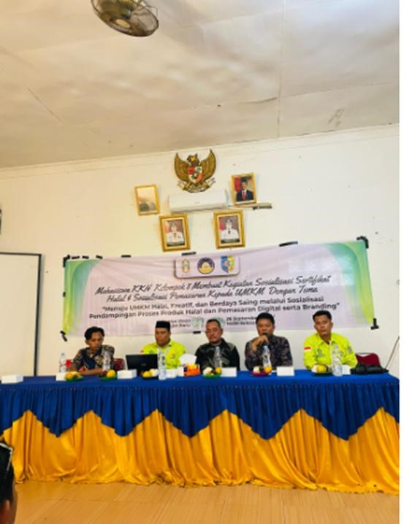

Figure 1. Panel of Keynote Speakers
Finally, the program was concluded with an evaluation and follow-up mentoring stage. Evaluation was conducted through discussions, reflections, and simple assessments to measure participants’ understanding and initial changes in practice. Follow-up mentoring was provided to assist selected MSMEs in refining their halal certification preparation, improving digital content, and finalizing branding concepts. This final stage aimed to ensure that participants were not only exposed to new knowledge, but were also able to apply business development strategies independently and sustainably.

3. RESULT AND DISCUSSION

3.1. Improving MSMe Owners’ Understanding of Halal Certification
The socialization activities produced a clear improvement in MSME owners’ understanding of both the procedures and the strategic benefits of halal certification. Initial discussions revealed that most participants were unfamiliar with the stages of applying for halal certification through the Sihalal platform, including the required documents, the step-by-step submission process, and the implications of formal halal legality for consumer protection. Many also perceived the process as complex and burdensome. Through structured explanations and guided simulations of form-filling on Sihalal, participants gradually recognized that the requirements were manageable and could be completed with proper guidance. They came to understand that halal certification does not only provide assurance of product safety and quality, but also strengthens business credibility, supports market expansion, and differentiates their products from uncertified competitors in an increasingly selective halal market. This change in perception was reflected in the growing number of participants who explicitly stated their readiness to prepare documents and submit halal certification applications after the program. These findings are consistent with previous studies emphasizing that halal legality has a positive effect on consumer trust, purchase intention, and the overall competitiveness of MSMEs in the halal industry (Septiani & Ridlwan, 2020; Muhnidin & Br. Pinem, 2024).

3.2. Using Digital Marketing to Promote MSME Products
The digital marketing training substantially enhanced participants’ skills in managing social media, producing simple promotional content, and understanding basic digital promotion techniques relevant to their business context (Sari & Lubis, 2024). Prior to the training, most MSMEs relied heavily on conventional methods such as word of mouth, printed materials, and informal local networks, with very limited use of online platforms. During the sessions, participants were introduced to practical steps for creating and optimizing business accounts on social media, using features such as stories, reels, paid promotions, and product catalogues, as well as designing simple visual content with clear messages. By the end of the program, they were not only able to create and manage business accounts, but also began to appreciate the importance of consistency in content publication, audience engagement, and basic performance monitoring. This outcome is in line with the findings of Panduwinata, Subroto, and Sakti (2025), who show that digital literacy is a key factor in the growth of halal MSMEs that utilize digital platforms. Likewise, Usmayanti and Pangestu (2022) emphasizes that digital marketing provides wider promotional reach, increases interaction with customers, and strengthens the competitive position of MSMEs in digital markets (Arista & Hermawan 2025; Husna et al., 2025; Usmayanti & Pangestu, 2022).

3.3. Strengthening Brand Identity through Creative Branding
The creative branding workshop (Figure 2) enabled MSME owners to gain a deeper understanding of brand identity, including the role of logos, colors, packaging, typography, and storytelling as key elements in shaping a coherent business image. At the beginning of the activity, observations indicated that most MSMEs did not have a clear or consistent brand identity; many products were sold with plain or non-informative packaging, lacked recognizable logos, and did not communicate any distinctive value proposition to consumers. Through step-by-step guidance, participants were introduced to basic principles of visual branding, such as simplicity, consistency, and relevance to target markets, as well as the use of narratives to highlight product uniqueness and halal attributes.

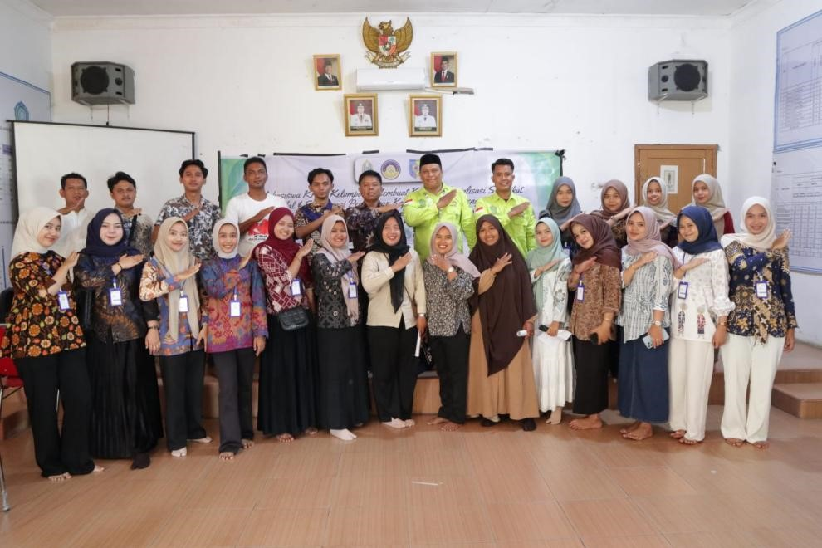

Figure 2. Participants of the workshop

By the end of the workshop, participants were able to design simple but more professional branding concepts, including draft logos, color palettes, and improved packaging ideas that better reflected the character of their products. This outcome is consistent with the findings of Amirudin et al. (2025), who emphasizes that branding has a significant influence on consumer perceptions in choosing halal products. In addition, Muhnidin and Br. Pinem (2024) find that halal certification combined with strengthened branding can enhance the image and added value of village-based MSME products, thereby improving their competitiveness in both local and wider markets.

3.4. Participant Engagement and Responses
The level of participant involvement throughout the program indicated a high degree of enthusiasm and commitment to learning (Figure 3). Participants were actively engaged in discussion sessions, where they shared their experiences, raised practical questions, and reflected on the challenges they face in managing their businesses. During the digital marketing practice, they took part in step-by-step exercises to create business accounts, develop simple content, and explore promotional features on social media platforms. In the brand identity design activities, participants collaboratively worked on logos, color choices, and basic packaging concepts, often discussing and revising their ideas based on feedback from facilitators and peers.

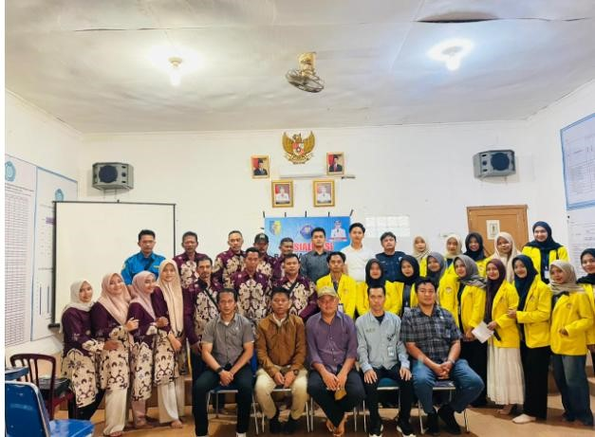

Figure 3. Participant Engagement and Responses

These observations suggest that a practice-based training approach, or hands-on learning, is more effective than lecture-based methods alone, particularly for adult learners and MSME actors who benefit from seeing direct applications to their business context. The opportunity to immediately apply new knowledge, experiment with tools, and receive real-time guidance appears to accelerate understanding and skill acquisition. This is consistent with Putri and Hidayat (2023), who state that practical methods can significantly speed up the improvement of MSME skills in implementing marketing strategies and fulfilling business legality requirements, thereby making capacity-building programs more impactful and sustainable in the long term.

3.5. Integration of Halal Certification, Digital Marketing, and Creative Branding
The analysis shows that enhancing the competitiveness of MSMEs cannot be achieved in a fragmented or isolated manner. The three key dimensions of halal certification, digital marketing, and creative branding are interdependent and must be integrated into a coherent and holistic strategy. Halal certification provides formal legitimacy, assures compliance with religious and safety standards, and strengthens consumer trust, particularly in markets where halal attributes are a primary consideration. Digital marketing, in turn, expands promotional reach beyond local boundaries, enables more targeted communication, and facilitates two-way interaction with consumers through social media and online platforms. Complementing these, creative branding contributes to clearer product positioning, stronger differentiation from competitors, and higher perceived added value through consistent visual identity and persuasive narratives.
When combined, these three elements form a reinforcing system in which legality enhances credibility, digital channels amplify visibility, and branding shapes perception and loyalty. This integrative approach is consistent with Panduwinata et al. (2025) and Amirudin et al. (2025), who argue that the synergy between legal compliance, digitalization, and strengthened brand identity constitutes an effective strategic model for improving the competitiveness of halal MSMEs, especially in an increasingly dynamic and competitive halal market environment.

4. CONCLUSION

This community service program successfully enhanced the knowledge, skills, and awareness of MSME owners in Binjai Baru Village regarding the importance of halal certification, the use of digital marketing, and the application of creative branding to improve business competitiveness. The halal certification outreach provided MSME actors with new understanding of the procedures, benefits, and urgency of halal legality as a guarantee of product quality and consumer trust. The digital marketing training proved effective in improving participants’ ability to use social media, marketplaces, and digital content as efficient promotional tools. At the same time, the creative branding workshop helped participants understand the importance of visual identity, product packaging, and storytelling in building a more professional brand image.
The results indicate that a practice-based training approach had a significant impact on the readiness of MSMEs to implement business development strategies. Participants showed a high level of enthusiasm and were able to make tangible changes in the way they manage and promote their products. Overall, the integration of halal certification, digital marketing, and creative branding proved to be an effective strategy for strengthening the competitiveness of halal MSMEs, particularly in rural areas with limited access to information such as Binjai Baru Village.
This program also underscores the importance of continuous mentoring to ensure that MSME actors can continue to develop and apply the knowledge they have acquired. In this way, the community service activities do not merely provide short-term education, but also lay the foundation for long-term capacity building among MSMEs. It is hoped that similar initiatives can be continued with a broader scope so that more MSMEs can benefit and be better prepared to compete in the rapidly growing halal industry.

Ethical Approval
This study was conducted in accordance with the ethical principles outlined in the Declaration of Helsinki.

Informed Consent Statement
Not applicable.

Authors' Contributions
SB contributed to the conceptualization of the community service program, coordination of field activities, and preparation of the main manuscript draft. TS contributed to the design and delivery of halal certification awareness activities and assisted in data collection and evaluation. NHA contributed to the digital marketing training modules, hands-on practice sessions, and analysis of program outcomes related to online promotion. MSS contributed to creative branding workshops, brand identity development assistance, and documentation of participant progress. DM contributed to program evaluation, data analysis, and final revision of the manuscript.

Disclosure Statement
The author(s) reported no potential conflicts of interest.

Data Availability Statement
The data used in this study are accessible from the international database mentioned in the Data and Methodology section.

Funding
This study did not receive any external funding.

Notes on Contributors

Surya Bakti
Surya Bakti is affiliated with Universitas Asahan

Tengku Syarifah
Tengku Syarifah is affiliated with Universitas Asahan

Nurul Hikmatul Alawiyah
Nurul Hikmatul Alawiyah is affiliated with Universitas Asahan

M. Sandi Syahputa
M. Sandi Syahputa is affiliated with Universitas Asahan

Dea Mutia
Dea Mutia is affiliated with Universitas Asahan

REFERENCES

Amirudin, A., Siradjuddin, S., & Muin, R. (2025). Branding and marketing opportunities for SME halal industry products: An insight consumer perception in South Sulawesi. East Asian Journal of Multidisciplinary Research, 4(7), 1001–1013. https://doi.org/10.55927/eajmr.v4i7.296
Arista, S. W., & Hermawan, S. (2025). Improving MSME performance based on digital marketing, intellectual capital, product innovation and competitive advantage. Jurnal Manajemen Bisnis, 16(2), 526–557.
https://doi.org/10.18196/mb.v16i2.25192
Aulia, A., Syah, F., & Mukti, J. (2025). Empowering MSMEs through digital marketing training for recipients of Ummul
Mukminin Aisyiyah Micro Waqf Bank capital to increase competitiveness in the digital market. Journal of Universal Community Empowerment Provision, 5(2), 83–88. https://doi.org/10.55885/jucep.v5i2.725
Fathoni, M. A., Priyatno, P. D., Faizi, F., Wiryanto, F. S., Rachbini, W., & Suryani, S. (2025). Unlocking barriers and strategies of halal certification for micro and small enterprises in Indonesia: Analytic network process approach. Problems and Perspectives in Management, 23(1), 169–180. http://dx.doi.org/10.21511/ppm.23(1).2025.13
Handy, M. R. N., Syaharuddin, S., Rajiani, I., & Putra, M. A. H. (2024). Digital marketing training to increase the marketing of MSME products in the Banua Anyar Village. Community Empowerment, 9(1), 1–8. https://doi.org/10.31603/ce.9341
Hidayat, M. T., & Witta, S. R. (2024). Halal certification and implications for MSMEs: A systematic literature review. Journal of Business Management and Islamic Banking, 3(2), 151–166. https://doi.org/10.14421/jbmib.v3i1.2373
Husna, F. K., Tamtama, N. N., Syahputri, R. B., & Al Hakim, H. (2025). Bridging the digital gap: Impact of digital marketing training on women-led MSMEs in Klaten. Journal of Economics Research and Policy Studies, 5(2), 533–544. https://doi.org/10.53088/jerps.v5i2.2170
Laksono, P., & Imanina, S. N. (2025). Digital marketing training for MSMEs in Mojosarirejo Village, Kemlagi District,
Mojokerto Regency. Sahwahita: Community Engagement Journal, 2(2), 57–65.
https://doi.org/10.69965/sahwahita.v2i2.104
Mahfud, I. (2025). The role of MSMEs (micro, small and medium enterprises) in improving the national economy. Journal of Economics and Business Letters, 5(5), 13–23. https://doi.org/10.55942/jebl.v5i5.915
Muhniddin, A., & Br. Pinem, R. K. (2024). The role of halal certification and brand image in increasing consumer trust: A case study of MSMEs Crispy Masjef Bananas. Journal La Bisecoman, 5(2), 201–209.
https://doi.org/10.37899/journallabisecoman.v5i2.1208
Nurjamjam, S. (2024). The influence of halal certification and halal quality assurance practices on business competitive advantage: Case study of MSMEs in West Java. Indonesian Journal of Halal Studies, 1(1), 69–80.
http://dx.doi.org/10.18326/ijhs.v1i1.69-80
Panduwinata, L. F., Subroto, W. T., & Sakti, N. C. (2025). Digitalization on micro, small, and medium enterprises (MSMEs): A systematic literature review. Indonesian Journal of Economics and Management, 2(1), 33–45.
https://doi.org/10.62951/ijecm.v2i1.435
Putri, R. A., & Hidayat, T. (2023). Training on optimizing digital marketing to improve MSME marketing. Jurnal Pengabdian Masyarakat Berkemajuan, 3(10), 1039–1048. https://doi.org/10.55927/jpmb.v3i10.11937
Sari, Y., & Lubis, A. (2024). Empowering MSMEs in Medan through digital marketing training. Community Empowerment, 8(2), 176–184. https://doi.org/10.31603/ce.10708
Septiani, D., & Ridlwan, A. A. (2020). The effects of halal certification and halal awareness on purchase intention of halal food products in Indonesia. Indonesian Journal of Halal Research, 2(2), 55–60.
https://doi.org/10.15575/ijhar.v2i2.6657
Silalahi, S. A. F. (2024). Do consumers need halal labels? Evidence from small and medium enterprises in a large Muslim environment. Journal of Islamic Marketing, 15(2), 378–395. https://doi.org/10.1108/JIMA-12-2021-0401
Usmayanti, V., & Pangestu, M. G. (2022). MSMEs digital marketing and entrepreneurship’s factor of performance: Jambi (Indonesia) perspective. Jurnal Ekonomi Pendidikan dan Kewirausahaan, 10(2), 155–166.
https://doi.org/10.26740/jepk.v10n2.p155-166
Utami, B., Setyariningsih, E., Hidayat, M. S., & Heru, T. H. (2023). Literature review: Halal culinary marketing strategy to improve the competitiveness MSMEs in Indonesia. International Journal of Social Science Research, 3(9), 4420–4430. https://doi.org/10.46799/ijssr.v3i9.530
Widigdo, A. M. N., & Triyanto, A. (2024). Knowledge and compliance: The increasing intention of MSME’s halal certification in Indonesia. International Journal of Business and Society, 25(1), 128–147.
https://doi.org/10.33736/ijbs.6904.2024

